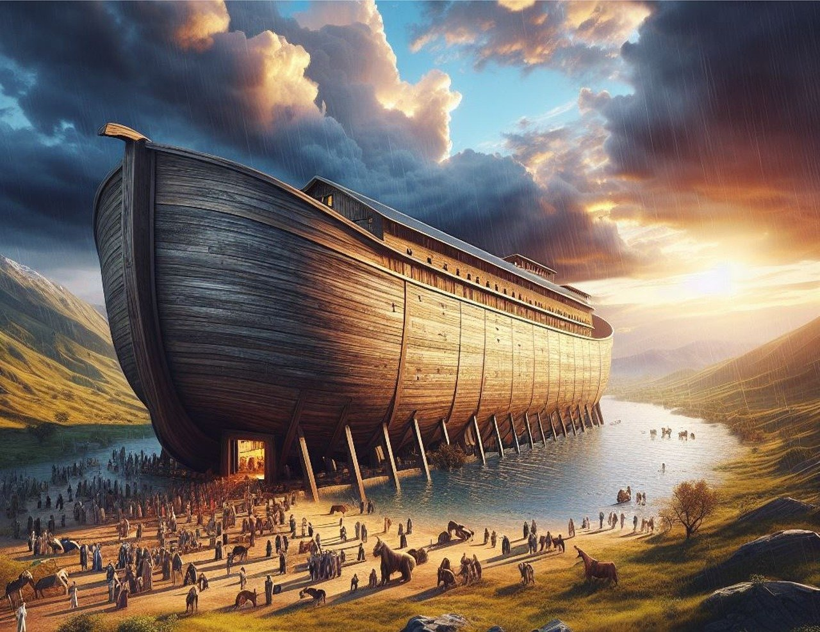

**THE WONDERS OF KENTUCKY**

**Arks, Boats, Bourbon and Bluegrass**

**MAY 12-17, 2025**

*The history and lore of “The Blue Grass State”, Kentucky is interwoven with legendary figures, like Daniel Boone, James Bowie, Abraham Lincoln, Stephen Foster, tobacco farms, fine bourbon, Thoroughbred horses, and the Kentucky Derby. The state is also home to a stellar system of universities, fortune 500 companies, state parks, natural resources and cultural attractions including the Ark Encounter & Creation Museums. Join us for the unique opportunity to explore up close and personal “Kentucky”!*

**Day 1 Monday - May 12, 2025 - Welcome Aboard!**

Welcome aboard as we travel to the Cincinnati, Ohio area for our next two-night stay. A Welcome Reception is planned for this evening! **(Kick-Back-Reception)**

**OVN: Drury Inn & Suites Cincinnati, Ohio**

**Day 2 Tuesday - May 13, 2025 - The Ark Encounter**

Today we enter the Blue Grass State of Kentucky and a visit to **The Ark Encounter**. From the moment you turn the corner, and the towering Ark comes into view, to the friendly animals in the petting zoo, to the jaw-dropping exhibits inside the Ark, you'll experience the pages of the Bible like never before. This marvel of engineering is seven stories tall and is a football field and a half long. It is the largest timber frame structure in the world. Get ready to experience close-up encounters with stunning animals. Some life-like recreations from Noah's day and many living-and-breathing animals from today. Enjoy an included lunch at your leisure at Emzara's Kitchen. Next, we visit the **Cathedral Basilica of Assumption** located in Covington, Kentucky. The Cathedral is famous for what is said to be the largest handmade stained-glass window in the world. There is also a pipe organ in each of the three gallery wings of the church, with one of the organs’ containing an astounding 65 ranks of pipes! The cathedral restoration program also earned it the 2002 Preservation Award. We return to our hotel for our overnight stay and the Managers Kick-Back-Reception. **(BL Kick-Back-Reception)**

**OVN: Drury Inn & Suites Cincinnati, Ohio**

**Day 3 Wednesday - May 14, 2025 - Kentucky Horse Park, Keenland Racetrack, Old Friends Thoroughbred Retirement Home, Claudia Sanders Dinner House**

Most places can only tell you stories about legends, but at the **Kentucky Horse Park**, they may just trot right by you. The park is hands-on, so you can touch the horses, smell the hay, and see firsthand the majesty of the horse. This is a place for all your senses! The park contains the Hall of Champions

Show, the Museum of the Horse, American Saddlebred Museum, the Big Barn and more. A cafeteria-style restaurant is available on the park grounds. Next, we’ll visit the prestigious **Keenland Racetrack** establish in 1936 and home to the largest Thoroughbred auction house in the world. Our final stop will be the **Old Friends Horse Farm**. This is a working farm and retirement ranch for at risk racehorses - those whose racing and breeding careers have come to an end. Here they are provided with the dignified retirement they deserve. Before arriving in Louisville for our three-night stay, we enjoy dinner at **Claudia Sanders Dinner House** its ***“finger licking good”.* (BD)**

**OVN: Hampton Inn Downtown Louisville, Kentucky**

**Day 4 Thursday - May 15, 2025 – Churchill Downs, Louisville Slugger Museum & Factory Tour, Brown Hotel**

This morning enjoy breakfast on the Backstretch at **Churchill Downs** with riders and jockeys. Our host will walk us around the stables and explain the daily routine of the trainers and riders. Then enjoy a special tour of this famous racecourse and Derby Museum. Why not try a mint julep at the Derby Café after the tour! You don’t have to be a baseball fan to love **Louisville Slugger Museum & Factory**. It’s iconic, it’s linked to legends, and it is one of Louisville’s best known tourist attractions. Our world-famous tour now begins with a thrilling movie that transports you to the forests and mills where every Louisville Slugger bat begins. After that, walk through the heart of our factory production line and check out never-before-seen steps in the bat-making process including the creation of our fan favorite mini-bats. Receive a mini bat at the end of tour. We return to our hotel to freshen up. Dinner this evening will be a special treat at the famous **Brown Hotel** and their popular “Kentucky Hot Brown”! **(BD)**

**OVN: Hampton Inn Downtown Louisville, Kentucky**

**Day 5 Friday- May 16, 2025 – Bardstown Kentucky - My Old Kentucky Home - Tour of Maker's Mark Distillery - Dinner Cruise**

This morning we travel to **Bardstown, Kentucky** to meet our local guide for a tour of this historic town. Our final stop on the tour will be the Visitors Center that serves as the main entry point to the popular historic mansion, "**My Old Kentucky Home"**. The home features over two centuries of antiques, paintings, and Federal Style architecture in addition to the gardens and outbuildings of the estate. Next, we tour one of the local distilleries, **Evan Williams**. Join us on Whiskey Row to meet Kentucky’s first licensed distiller. Taste bourbons from the Evan Williams award winning portfolio. This evening, we enjoy a **Dinner Cruise** on the mighty Ohio River with the City of Louisville skyline in the background. **(BD)**

**OVN: Hampton Inn Downtown Louisville, Kentucky**

**Day 6 Saturday – May 17, 2024 -Travel Home**

We bid farewell to the blue grass state and travel home arriving in the late afternoon! **(B)**

**TRAVEL PROTECTION PLAN:** The Travel Protection Plan is not included but is available and strongly recommended. There are three options:

#1 Sign up for the insurance and pay the premium at the time you register for the

tour and pre-existing condition waiver is included (refer to insurance flyer for

details)

#2 Sign up for the insurance any time after you make our initial trip deposit and

Prior to the final date for trip registration and received the same travel insurance

inclusions except the pre-existing waiver will not apply

#3 Decline the Travel Protection Plan

The trip interruption and medical cancellation insurance premium is non-refundable unless the entire tour cancels. We offer a travel protection plan through Trip-Mate Insurance/a division of United States Fire Insurance Company Eatontown, NJ. Anu surcharges and/or tax increases received suppliers for the package (airlines, cruise companies, hotels, etc.) may result in an increase in the per person price of your tour package. For those individuals who may have purchased the Travel Protection Plan this may also result in an increase in your Travel Protection Plan premium. Please refer to [www.tripmate.com/Plan TPD013](http://www.tripmate.com/Plan%20TPD013) for information regarding detailed coverages and limitations to the insurance policy. Waiver of Pre-Existing Condition Exclusion. The exclusion for pre-existing conditional will be waived provided

1. Your payment for this plan is received with your reservation
2. You are not disabled from travel at the time your plan premium is paid