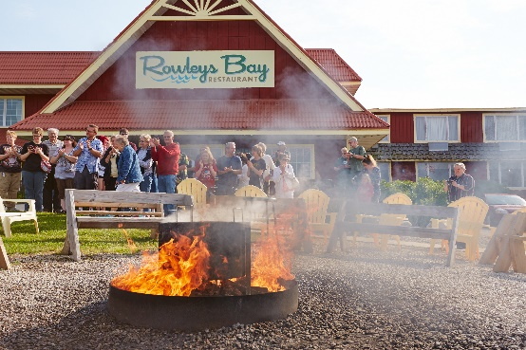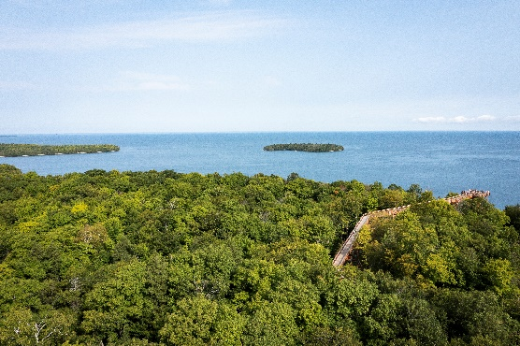
Photo Credit Destination Door County
Door County Fall Foliage October 4 – 7, 2022
“Cape Cod of the Midwest”
4 Days/3 Nights

Tour Highlights:
8 Meals: 3 Breakfasts/2 Lunches/3 Dinners
Green Bay Packer Hall of Fame
Trolley Tour including Peninsula State Park
Rowley’s Bay Resort Fish Boil
Lunch at Al Johnson’s (Goats on the Roof)
Scenic Boat Cruise along Millionaire’s Row and the West Islands
Peninsula Players Theater Performance
Taxes and Gratuities on Included Accommodations, Attractions & Meals
Luggage Handling
Deluxe Motorcoach Transportation
Per Person Prices:
$1155.00 DOUBLE OCCUPANCY
$1039 QUAD……$1079 TRIPLE…….$1399 SINGLE

Travel Insurance is available
and strongly recommended
(See page 2 for details)
For Additional Information
or to Make a Reservation, Contact:
Tri-State Travel
1-800-779-4869

Day 1 - October 4, 2022 We’re off on our adventure to beautiful Door County, Wisconsin. Home to 5 state parks, 12 lighthouses, numerous cherry and apple orchards, 5 wineries and an abundance of beautiful scenery, Door County has become one of most popular tourist destinations in the United States. Our first overnight will be in Green Bay, Wisconsin, and upon arrival, we will visit the Packers Hall of Fame, the very first Hall of Fame built to honor a football team. Afterwards, we check into the Radisson Hotel, adjoining the Oneida Casino. Dinner is included, and then you are free to enjoy the evening for gaming or relaxing. (D)

Day 2 – October 5, 2022 Enjoy a hot breakfast before loading the coach and heading to the Door County Peninsula. Upon arrival in Egg Harbor, board the Door County Trolley for a guided tour that will visit the best of Door County and include Peninsula State Park, Wood Orchard Market, lunch and a stop at a Brewery for some beer tasting. Tonight, we will enjoy a delicious Door County Fish Boil at the Rowley’s Bay Resort, our home for the next two nights. Other entrees will also be available for those who don’t care for fish. (B,L,D)

Day 3 - October 6, 2022 A delightful breakfast buffet is served at the hotel this morning before we begin another day of touring. Our first stop will include Shopping Time, followed by lunch at Al Johnson’s Swedish Restaurant in nearby Sister Bay. Not only is the food fantastic but the goats grazing on the sod roof make it a delightful stop for all ages. Return to Fish Creek to the Scenic Boat Tours dock for a cruise along the shores of Green Bay. View the beautiful shore homes along “Millionaire’s Row,” the Strawberry Islands, and the Eagle Bluff Lighthouse from the water. Our last night in Door County has us enjoying dinner at the English Inn in nearby Fish Creek, Wisconsin, followed by an evening of entertainment at the Peninsula Players Theater located within Peninsula State Park (Show TBA). (B,L,D)

Day 4 - October 7, 2022 Take part in the hotel’s buffet breakfast before check-out. Unfortunately, it is time to head back home. Before we depart The Door, we make one more stop for local produce and baked goods at the Seaquist Orchard and Farm Market. Our travel day passes quickly as we sit back, relax and visit with our new-found friends. We arrive back home in the late afternoon. (B)
Photo Credit Destination Door County

The Travel Protection Plan: is not included but is available and strongly recommended. Premium is non-refundable unless the entire tour cancels. We offer a travel protection plan through Trip Mate Travel Insurance/a division of United States Fire Insurance Company, Eatontown, NJ. Any surcharges and/or tax increases received from suppliers for this package (Airlines, Crise Companies, Hotels, etc.) may result in an increase in the per person price of your package.
For those individuals who may have purchased the Travel Protection Plan, this may also result in an increase in your Travel Protection Plan Premium. Please refer to www.tripmate.com/plan TPD13 for information regarding detailed coverages and limitations to the insurance policy.
Waiver of Pre-Existing Condition Exclusion. The exclusion for pre-Existing Conditions will be waived provided (a) your payment for this plan is received within seven days of the date your initial payment or deposit for your trip is received; and (b) You are not disabled from travel at the time your plan payment is paid.
*Tri-State Travel reserves the right to change any arrangements listed in this itinerary. Should conditions necessitate changes, substitution of equal value or cancellations of the arrangements may occur.

*Tri-State Travel reserves the right to add any fuel surcharges that we receive from all our vendors, i.e. airlines, cruise lines, motorcoach companies, etc. Additional costs may be added any time prior to travel.

